
Department of Computer Science and Engineering
Lab Report
Lab Report No | : | 02
Lab Report Name | : | Bisection Method Implementation. F(x)= 3x-cos(x)-1.
Course Title | : | Numerical Methods Sessional
Course Code | : | CSE 226
Name | : | Gazi Rishad Kaiser
ID | : | 1120047
Level | : | 2 | Term | : | 2 | Section | : | A | Group | : | 2
Date of Submission | : | - 2026 | Semester | : | Spring | Year | : | 2026

Problem-01: Bisection Method Implementation. F(x)= 3x-cos(x)-1.
Key Learnings:
- This program helped in understanding the Bisection Method, which is used to find the root of an equation by repeatedly dividing an interval into two equal parts.
- The importance of selecting a valid interval (a,b) was learned. For the Bisection Method to work correctly, the function values at the two endpoints must have opposite signs.
- The program showed how loops can be used to perform repetitive calculations and gradually improve the accuracy of the root.
Source Code: Input & Output:
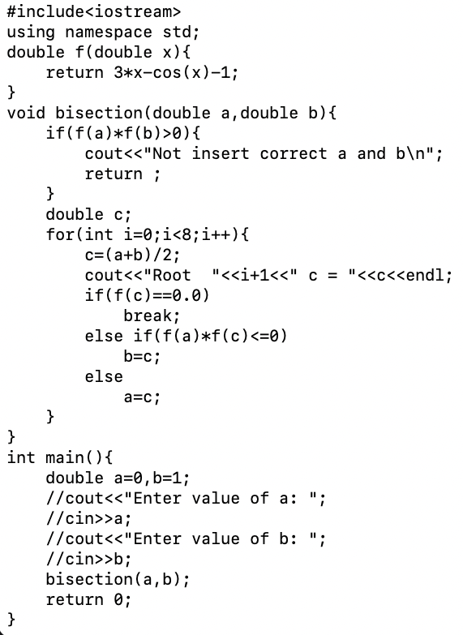
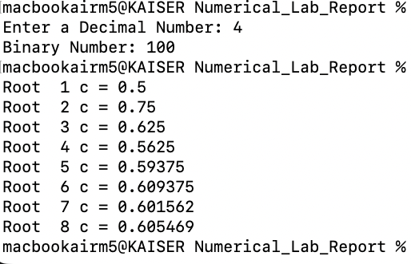

Result Analysis:
Result Analysis:
When the program was executed, the values of a =0 and b=1 were provided as the initial interval. The function f(x)=x3+cos(x)−1 was evaluated at different points within this interval. The midpoint of the interval was calculated in each iteration, and the interval was continuously reduced based on the sign of the function values. After several iterations, the root value gradually approached the actual solution. The interval became smaller in each step, which increased the accuracy of the result. As a result, an approximate root of the equation was successfully obtained and displayed on the screen.
